Experiment 12: Port Scanning Tools
Aim: To perform different port scanning techniques using Nmap in Kali Linux and understand how TCP, UDP, SYN, ACK, FIN, NULL, Xmas, RPC, and Idle scans work.
Commands
1. TCP SYN Scan
Command:
sudo nmap -sS 10.0.2.15
Explanation:
- sudo runs Nmap with administrator privileges.
- nmap is the network scanning tool.
- -sS performs a TCP SYN scan, which sends SYN packets to check the status of ports.
- 10.0.2.15 is your Kali Linux IP address.
Screenshot:
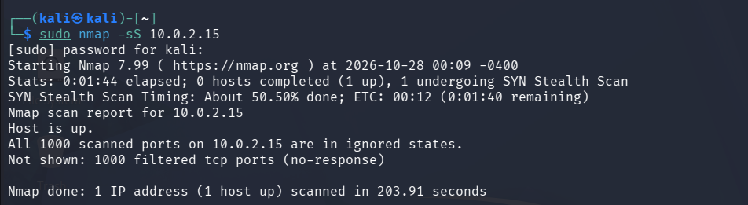
2. TCP Connect Scan
Command:
nmap -sT 10.0.2.15
Explanation:
- -sT performs a TCP connect scan.
- It attempts to establish a complete TCP connection to identify accessible ports.
- This scan is useful when SYN scanning is unavailable.
Screenshot:
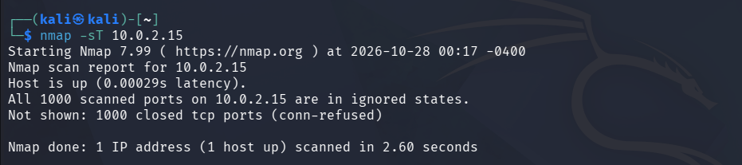
3. UDP Scan
Command:
sudo nmap -sU -F 10.0.2.15
Explanation:
- -sU scans UDP ports, commonly used by services such as DNS.
- -F scans a smaller list of commonly used ports to reduce scanning time.
- UDP scans can take longer than TCP scans because UDP services may not respond to probes.
Screenshot:
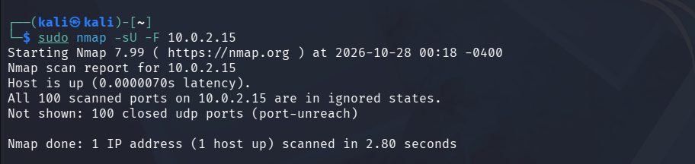
4. TCP ACK Scan
Command:
sudo nmap -sA 10.0.2.15
Explanation:
- -sA performs a TCP ACK scan.
- It helps determine whether ports are filtered by a firewall.
- It generally identifies ports as filtered or unfiltered; it does not directly determine whether a port is open.
Screenshot:
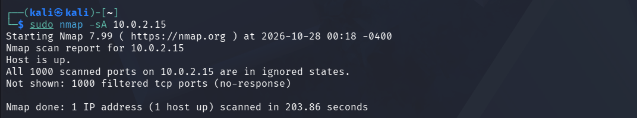
5. TCP FIN Scan
Command:
sudo nmap -sF 10.0.2.15
Explanation:
- -sF sends TCP packets with the FIN flag set.
- It examines how the target responds to these packets.
- Results can vary depending on the target operating system and firewall.
Screenshot:
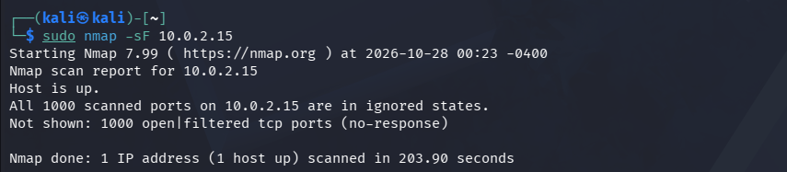
6. TCP NULL Scan
Command:
sudo nmap -sN 10.0.2.15
Explanation:
- -sN sends TCP packets without any flags set.
- It observes the responses to help infer port states.
- Some systems do not respond in the expected way, so results may be inconclusive.
Screenshot:
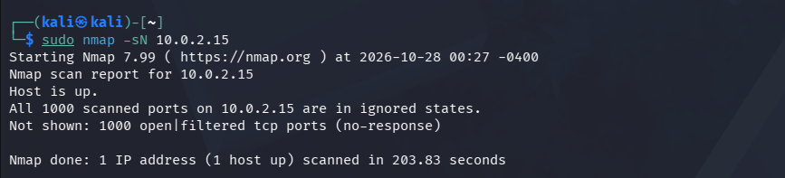
7. TCP Xmas Scan
Command:
sudo nmap -sX 10.0.2.15
Explanation:
- -sX sends TCP packets with the FIN, PSH, and URG flags set.
- It is called an Xmas scan because multiple TCP flags are switched on.
- The response can help Nmap infer port states.
Screenshot:
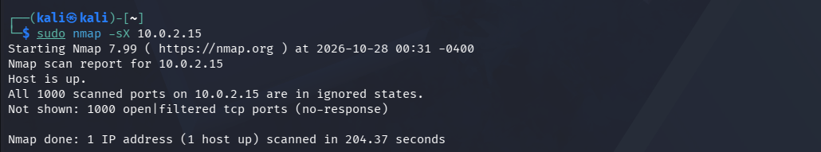
8. RPC Service Scan
Command:
sudo nmap -sV -p 111 10.0.2.15
Explanation:
- -sV attempts to identify the service and its version.
- -p 111 scans port 111, commonly associated with RPC port mapping.
- This checks whether an RPC-related service is available on that port; it does not guarantee that RPC is running.
Screenshot:
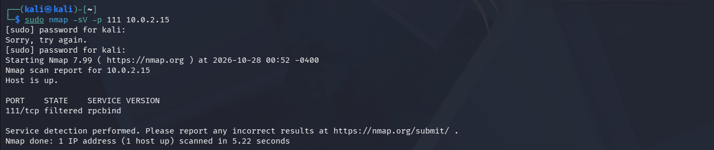
9. Idle Scan
Command template:
sudo nmap -sI ZOMBIE_IP 10.0.2.15
Explanation:
- -sI performs an Idle scan using a separate, suitable host as an intermediary.
- ZOMBIE_IP must be replaced with the IP address of a suitable host that you own or have permission to use.
- Your target remains 10.0.2.15.
- This scan will not work just by typing ZOMBIE_IP; a suitable intermediary host is required. If you do not have one, explain the technique in your record and ask your instructor for an approved lab host.
Screenshot:
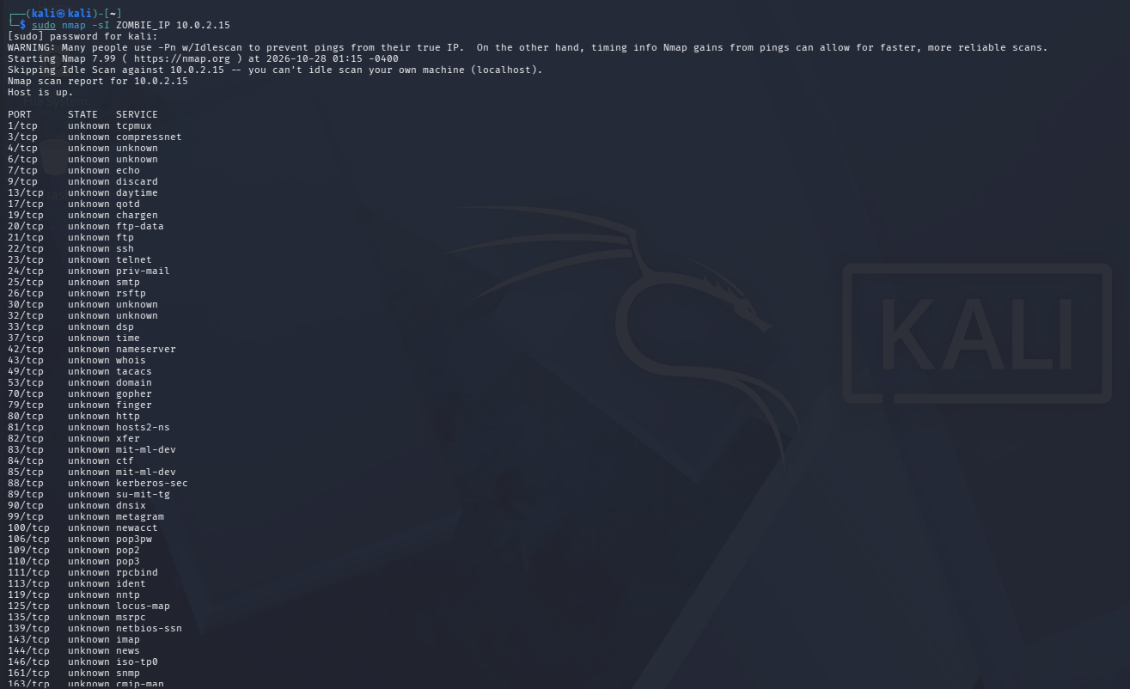
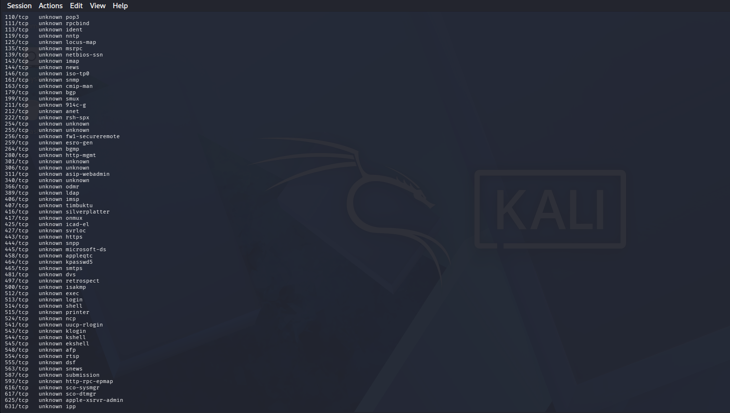
Result: Different Nmap port scanning techniques were studied and tested against the Kali Linux IP address 10.0.2.15. The scans demonstrate how Nmap examines TCP and UDP ports, checks firewall filtering, and identifies services. The actual port states and scan results were recorded from the terminal.

